Instructor SLO Screen in Seaport³ for Web Design BC171 – Spring 2012

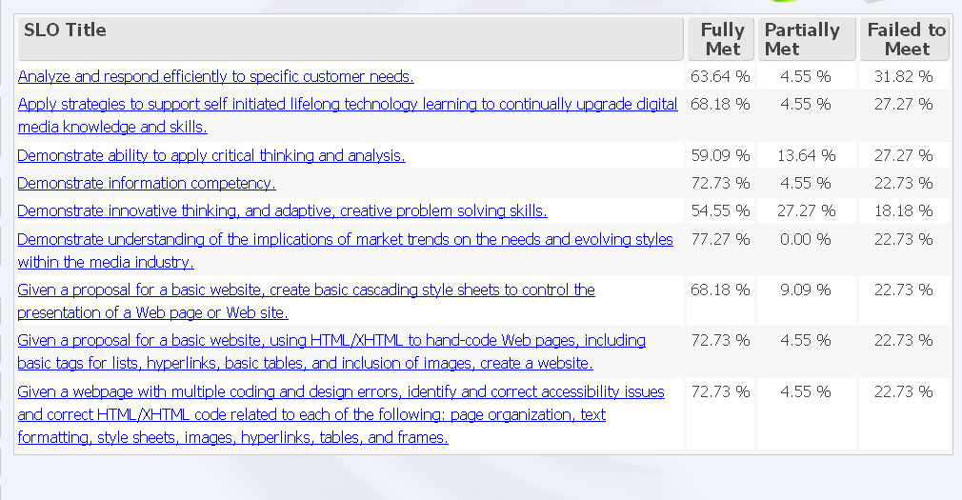

Instructor SLO Screen in Seaport³ for Beg. Word BC147 – Spring 2012

